Guidelines for Assisting Those with Accessibility Needs



Provided by the Office of
Ranking Member
Senator Michael B. Enzi
of the HELP Committee

Prepared August 2010
Introduction

Dear Colleague:

In an effort to include every individual who comes to visit the nation’s Capitol or our state, committee or personal offices to take part and engage in our daily dialogue, it is important that we accommodate individuals who have a wide variety of accessibility needs. This may include someone who uses a wheelchair, has difficulty hearing or seeing, or even has respiratory issues. Ensuring our ability to interact and assist people with accessibility needs requires that we are prepared, in advance, to meet their needs with everything ranging from appropriate language and basic etiquette to guaranteeing they are included in our emergency preparedness plans to both considering and providing for visitors in the design of our rooms and buildings.

This manual will assist you in preparing for visitors who would appreciate the time and attention your office and staff can offer to better help them, make sure they are comfortable, and ensure that their time in Washington, D.C. is as enjoyable and informative as possible.

With this in mind, we submit to you a revised, improved, and updated version of the Accessibility Manual* in recognition of the 20th Anniversary of the Americans with Disabilities Act (ADA), which took place on July 26, 2010. I hope the material contained in this manual will serve as an invaluable resource for the Senate family.

Sincerely,

Michael B. Enzi
United States Senator
*This is not a legal document and does not purport to give legal advice or impose legal obligations. To the extent any suggestions in these Guidelines are inconsistent with any procedures the U.S. Capitol Police (USCP), the Office of Police Operations, Security and Emergency Preparedness (POSEP), the Office of Congressional Accessibility Services, or other similar congressional entities establish, the procedures established by those entities are controlling.

Table of Contents

General Accessibility…………………………………………....5

Emergency Evacuation Procedures…………………………..11

Etiquette.………………………………………………………..25

Language……………...………………………………………...27

Alternative Formatting..……………………………………….28

Physical Accessibility…….……………………………………30

Accessible Hearing Rooms….………………………………...32

Enrichment and Training……………………………………...33

Accessible Directions…………………………………………..34

References………………………………………………………39

Acknowledgements……………………………………………41

Index

Accessible Touring………………………………………………5

Accessible Parking.………………………………………………5

Wheelchair Loans.……………………………………………….6

Accessible Restrooms.…………………………………………...6

Accessible Entrances….……….………………………………...6-7

Assistive Listening Devices/Sign Language Interpreters.....8-9

Accommodation Requests for Staff……………………...…...10

Evacuation Elevator Procedures…….………..…………...11-12

Evacuation Checklist……………….…………………………..12

Internal Relocation Sites……………………………………….13

Emergency Evacuation Elevator Maps - Capitol………..14-15
Visitor Center…............16-18
Senate………….....19

Escape Hood Public Cache Photos – Senate……………..20-22
Capitol………………..23

Victim Rescue Unit (VRU) Public Caches – Senate………....24

Braille…………………………………………………………....29

Accessible Directions……………………………………....34-38

General Accessibility

The Capitol Complex is a difficult facility to navigate. The next few pages of the manual include services to help people with accessibility needs navigate the Capitol Complex better. In providing accommodations, do not assume you know what the individual wants. Always ask and provide options.

Accessible Tours
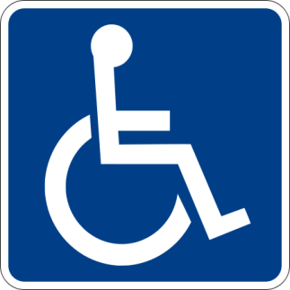
- All public tours of the Capitol offered by Visitor Services in the Capitol Visitor Center (CVC) are accessible. In addition, tours are offered by the Office of Congressional Accessibility Services (OCAS) (202-224-4048; Crypt of the Capitol). OCAS staff can also assist in making staff-led tours accessible.
- What is the difference between the public tours and those offered by OCAS? OCAS tours can be customized to meet the needs of the individual(s) with disabilities. For example, for someone who is blind, OCAS can give a tour that is more descriptive. The choice to take a tour with OCAS should always be made by the individual with the disability. To get more information about OCAS and the services they offer:
  - From Webster click on the “Sergeant at Arms” tab.
  - Select “Accessibility Services.”
  - Do not hesitate to call OCAS with any questions.
- Brochures in alternative formats are available in the Capitol and the CVC. In addition, OCAS produces a brochure “Washington Highlights Tour Information for Visitors with Disabilities” which provides accessibility information on most major tourist attractions in Washington DC. Visitors may find this information to be helpful in planning their visit. Copies of Washington Highlights are available from OCAS.

Accessible Parking
- For visitors with accessibility needs, offices may arrange accessible parking for visitors coming to their offices for appointments by contacting the Sergeant at Arms Parking, Transportation and Fleet Operations office at 4-8888.
- If constituents or large groups of people visiting the Capitol Complex have accessibility needs that prevent easy travel from Union Station, Garfield Circle or Peace Circle, vehicle access or transportation into the Senate Perimeter can be requested through the Sergeant at Arms office.
  - From Webster click on the “Sergeant at Arms” tab.
  - Select “Special Accommodations Access.”
  - For more information, please visit http://webster.senate.gov/SenateCampusAccess/
- There is a shuttle service that is operated by the Visitor Services office between Garfield Circle (where buses drop off visitors) and the CVC entrance. Shuttle rides are also available from the CVC to Peace Circle (where tour buses pick up visitors). Questions about the shuttle service can be directed to OCAS.

Wheelchair Loans
- Wheelchair loans are available for staff, interns and visitors from OCAS. Staff and interns should visit the OCAS office in the Crypt of the Capitol to borrow a chair.
- The CVC also has wheelchairs that can be borrowed at the Coat Checks counter just inside the entrance of the CVC. They are available for constituents on public tours or visiting the House and Senate Galleries.

Accessible Restrooms
- There is at least one accessible restroom on every floor in every Senate office Building. Staff should know where the closest accessible restrooms are in relation to their office.

Accessible Entrances (Does not include the Capitol Visitor Center)
- Accessible entrances are located throughout the Capitol Complex. Below is a helpful map that highlights accessible entrances located throughout the Capitol, Senate and House Office Buildings. The location of accessible entrances for Senate Office Buildings are:
    - Dirksen – Corner of First Street NE, and C Street NE
    - Hart – Second Street NE, midway on the block between C Street NE and Constitution Ave. NE
    - Russell – Corner of Delaware Ave. NE and Constitution Ave. NE
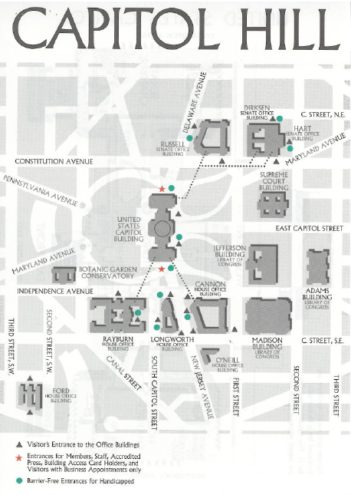

Options for Individuals who are Hard of Hearing
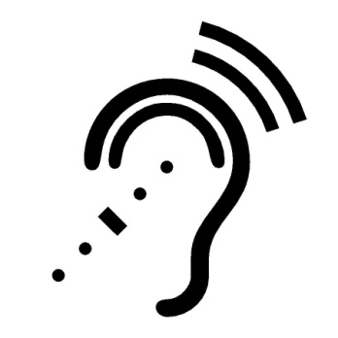
- Assistive Listening Devices (ALDs) are amplification instruments designed to increase sound in many listening situations. There are different kinds of ALDs that can be used in a small meeting, during a tour, or at a committee hearing.
- OCAS has an FM System which is available for short-term use by staff and visitors. Contact OCAS for more information about ALDs.
- Induction Loops are another alternative used to provide sound amplification in most Senate hearing rooms. Individuals with a “T-switch”, (telecoil) on their hearing aid or cochlear implant can automatically access this frequency for direct amplified sound input. Gallery #6 in the Senate Gallery also has an Induction Loop. For more information about Induction Loops in the Senate contact the Architect of the Capitol (202-228-1793, http://www.aoc.gov/ )
- The Sergeant at Arm’s Recording Studio can help you understand how television broadcasts of Senate activities and committee hearings are made accessible to people who are deaf or hard of hearing through the use of Real Time Captioning. For more information contact the Recording Studio at 202-224-4977.

Options for Individuals who are Deaf

- When requested, it is suggested that a Senate Committee, state or personal office provide sign language interpreters for constituents. For questions about a Senate entity’s obligation under the law to provide any accommodation, contact the Senate Chief Counsel for Employment at 202-224-5424.
- Sign language interpreters are available for official Congressional business, including staff meetings, press conferences, instructional classes, job interviews from OCAS (202-224-4048).
- Sign language interpreters are also available for witnesses at hearings.
- The provision of sign language interpreters for audience participation at committee hearings is the responsibility of each individual committee.
- OCAS can help Senate offices and committees with securing qualified sign language interpreters.
- Offices are encouraged to contact OCAS to receive a list of interpreting service providers for their state and district offices.
- Please be aware that outside services contracted to provide communication access should be with certified vendors and must be paid with the appropriate office budget.
- A form to schedule an interpreter can be obtained online at OCAS.
  - From Webster search for “Accessibility Services”
  - Click on “Sign Language Interpreters”
  - Call OCAS in inquire about services before submitting an interpreter request form.
  - Please make requests as far in advance as possible. However, do not hesitate to call OCAS for immediate assistance if needed.
- Teletypewriter (TTY): Both training and support are offered by OCAS. OCAS also offers monthly functionality checks if requested by an office.
- Video Relay Interpreting services are available through the Federal Relay Service (FRS) (800-877-8339, www.gsa.gov/frs) The FRS is available for use by Federal employees as well as members of the general public who wish to contact a Federal entity. It allows equal communication access for people with hearing and speech disabilities.
- Communication Access Realtime Translation (CART) services are available in the Washington, DC area as well as communities across the United States. Please contact OCAS (202-224-4048) for assistance in securing these services.

Options for Individuals with Low Vision or Who are Blind
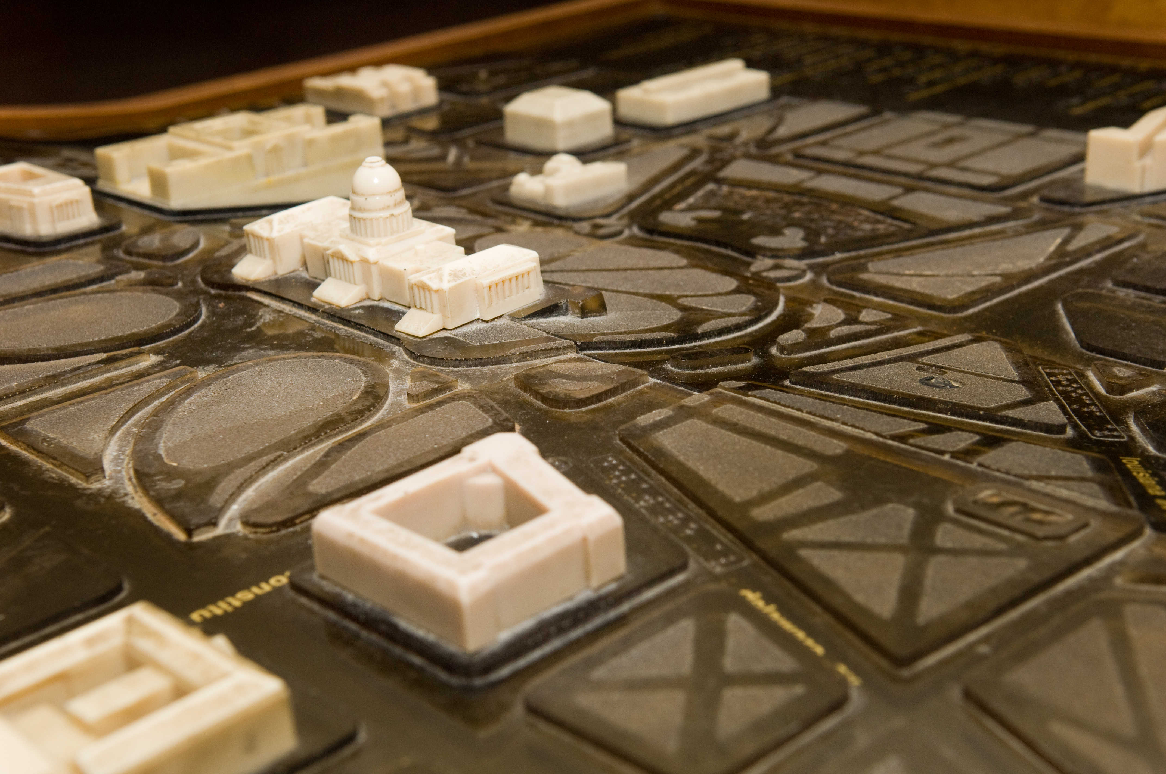
- Tactile Displays – These displays consist of hard plastic inlays showing the land’s topography of Capitol Hill and the surrounding area. These displays are located in: The Crypt of the Capitol (located directly below the Rotunda), 1st floor of the Hart Senate Office Building (located adjacent to the Disbursing Office), and the South Capitol Street Entrance of the Rayburn House Office Building.
- Alternative Formats – All brochures and other resource material are available from OCAS in braille, large print, , and HTML (HyperText Markup Language). Remember to ask the individual with low vision or who is blind what is needed because the individual may not read braille.
- Conversion – To have a document converted to Braille, please contact OCAS for guidance. They will assist with the conversion process after which you will take it to the Printing, Graphics and Direct Mail Office (SD-G82, 202-224-6138). PGDM requires approximately 7 days to produce materials in braille.

Options for Individuals Who Request Accommodations
- For help determining and fulfilling accommodation requests for Senate employees or interns, please contact Jean Manning of the Senate Chief Counsel for Employment (202-224-5424).
- To request technology equipment for Senate employees and interns, please contact Jean McComish in the Human Resources Department of the Sergeant at Arms (SAA) Office. (SH-142, 202-224-2889).
- For questions on physical accessibility, accessible entrances, accessible hallways, etc. throughout the Senate office buildings contact Takis Tzamaras (202-224-2021) in the office of Architect of the Capitol (AOC).
- Furniture accommodations and ergonomic assessments are also provided by the Architect of the Capitol. Please contact the Superintendent's Furniture Division (202-224-1213).
- For further information on providing accommodations for Senate employees and interns please visit (http://www.dol.gov/odep/).
  - From this link, click on “Employer.”
  - Click “Employing People with Disabilities.”
  - Select “Accommodations.”

Emergency Evacuation Procedures

Evacuating staff, interns and/or visitors with accessibility needs poses unique challenges in any work environment. It is particularly difficult on Capitol Hill because of the large number of visitors who may be in our buildings at any given time. Staff and interns must be familiar with specific evacuation procedures. Within one week of hiring new staff or interns, the office manager should contact the Office of Police Operations, Security and Emergency Preparedness (POSEP) (202-228-6737) regarding a briefing for evacuating staff, interns or visitors with accessibility needs.

Prior to an Evacuation
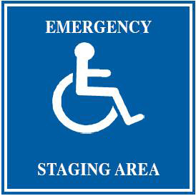
- Evacuations occur with little or no warning. It is nearly impossible to predict staff, interns or visitors’ exact location when an evacuation is initiated. Office staff and interns should become familiar with the locations of Emergency Staging Areas and Emergency Evacuation Elevators throughout the Capitol, Senate Office Buildings, Postal Square and the CVC. Emergency staging areas are marked with blue placards (pictured).
- Make sure that emergency evacuation procedures are posted in each office suite in areas accessible to staff, interns and visitors. The exit route and location of the emergency evacuation staging areas within the building should be readily available to visitors as well as staff.
- Each office should identify an evacuation leader who assists those with accessibility needs in the event of an emergency. It is important to practice emergency evacuation procedures with your staff and interns so they are prepared in advance of an emergency situation.

Evacuation Elevator Procedures
- Two elevators in each Senate office building have been designated as emergency staging areas. The Capitol Visitor Center has six emergency staging areas.
- Capitol Police will take control of the elevator using special keys. Starting at the building’s highest floor, the officer will stop the elevator on every floor and look for individuals waiting at the emergency staging areas.
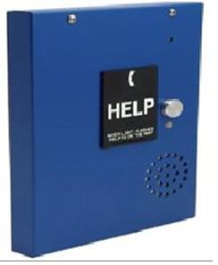
- Emergency Call Boxes (pictured) are available at each staging area, and provide two-way communication to US Capitol Police. Press the silver button to activate the device.
- Most Emergency Evacuation Elevators are freight elevators with the capability to hold more persons than typical passenger elevators.

Evacuation Checklist: For Staff, Interns and Visitors with Accessibility Needs
When you hear the alarm sound:
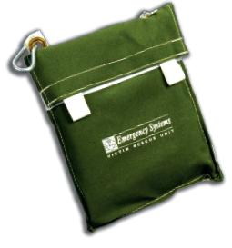
- The staff evacuation leader should locate staff, interns and visitors with accessibility needs.
- Take the VRU (Victim Rescue Unit) package, wireless emergency annunciator/pager, and staff ID with you.
- Move with your evacuation partner toward the closest Emergency Staging Area to take the Emergency Evacuation Elevator.
- Upon arrival of the Emergency Staging Area, hit the blue Emergency Call button that will directly connect you to the US Capitol Police Emergency Line.
- If the nearest Emergency Staging Area or Emergency Evacuation Elevator is inaccessible, listen for guidance regarding the use of alternate elevators from United States Capitol Police (USCP).
- You may don your VRU anytime you feel threatened by smoke; however, remember your best option is to relocate away from the threat.
- VRUs are not meant to replace the escape hood. In the event of a chemical, biological, radiological or nuclear threat, and at the request of the Capitol Police, escape hoods should be donned.
- Wait for the USCP officer to arrive; if needed, have your buddy assist you onto the Emergency Evacuation Elevator.
- Once on the elevator, the officer will take you to the building’s exit floor where you can safely leave the building and report to your office assembly area.

Procedures to move to Internal Relocation Sites
Structural modifications have been made in select locations throughout the Capitol Complex to allow for short-term (2-3 hour) sheltering in response to respiratory threats. In the event of a respiratory threat, the U.S. Capitol Police (USCP) may direct building occupants to quickly report to these Internal Relocation Sites.

When you hear the alarm sound:
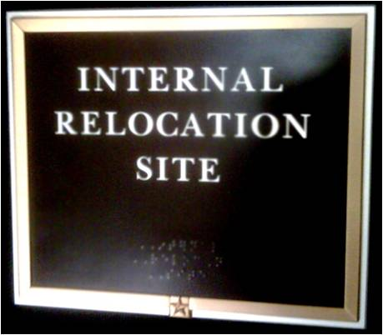
- The evacuation leader should locate staff, interns and visitors with accessibility needs.
- Take the VRU package, wireless emergency annunciator/pager, and staff ID with you.
- Move with your evacuation partners to the closest internal relocation site to you. These sites are marked dark brown placards labeled “Internal Relocation Site” (pictured above). Staff in the Capitol, Capitol Visitors Center, Postal Square, or in the Page Dorm or Senate Employee Child Care center follow direction of US Capitol Police.
- During an internal relocation, elevators are still on normal operation. For staff, interns and visitors with accessibility needs, please use the following internal relocation sites:
HART - SH-216
DIRKSEN - SD-G50
RUSSELL - SR-236, SR-332, SR-325, SR-385, SR-432, SR-485
CAPITOL - Move to CVC via elevators
CVC - Shelter in Place
POSTAL SQUARE - Shelter in Place

- If the nearest Internal Relocation Site is inaccessible, listen for guidance regarding the use of alternate relocation sites from United States Capitol Police (USCP).

If you have questions or concerns about accessibility options or need special accommodations during any of the protective actions, please call POSEP at 8-6737.

Emergency Evacuation Elevator Map – The Capitol

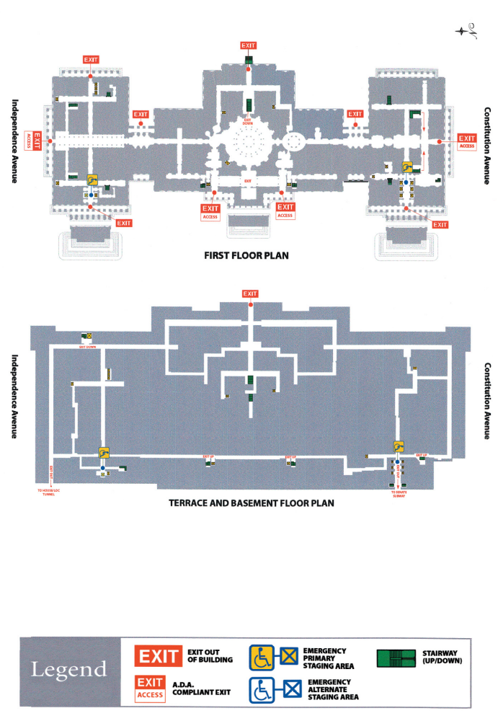
Emergency Evacuation Elevator Map – The Capitol
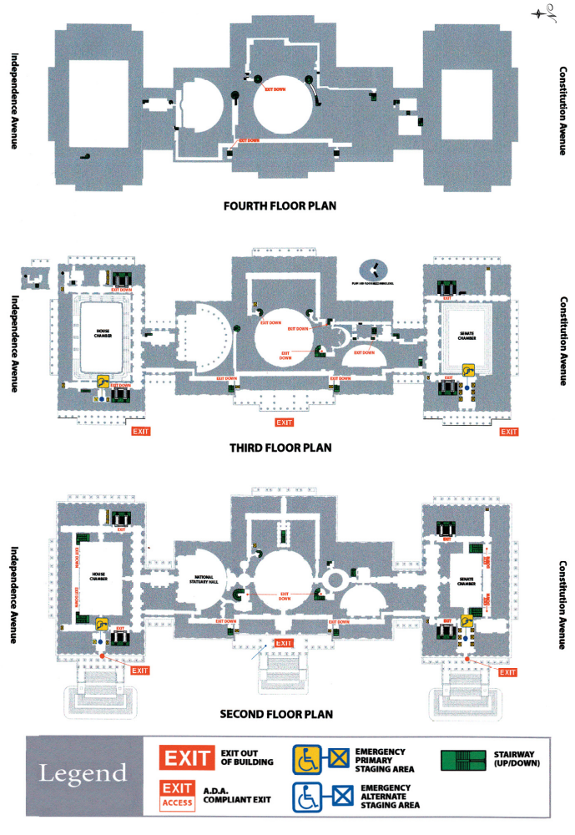
Emergency Evacuation Elevator Map – Capitol Visitor Center
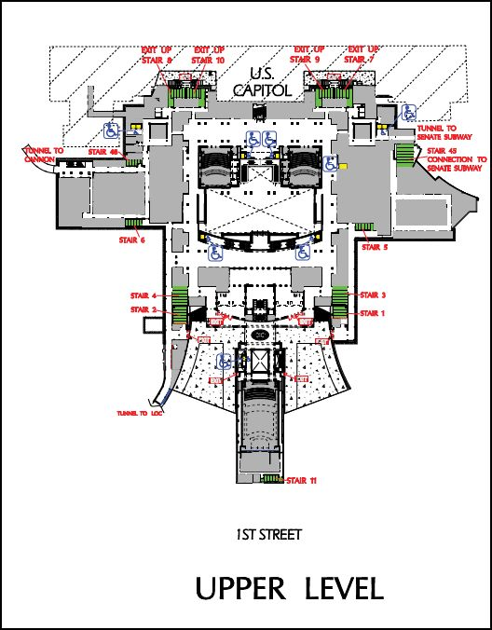
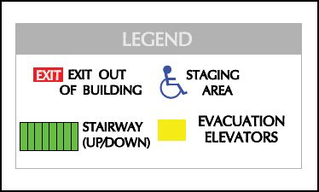

Emergency Evacuation Elevator Map – Capitol Visitor Center
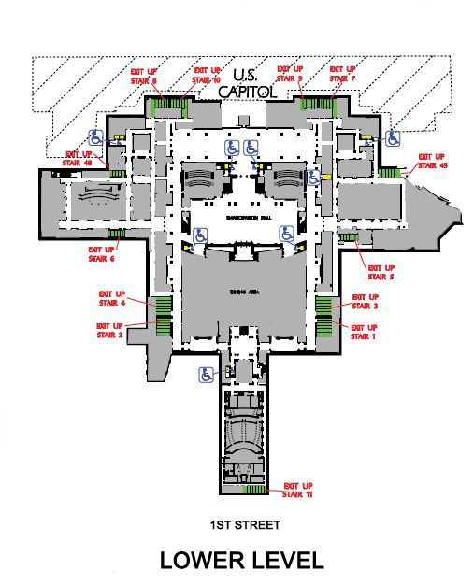

Emergency Evacuation Elevator Map – Capitol Visitor Center
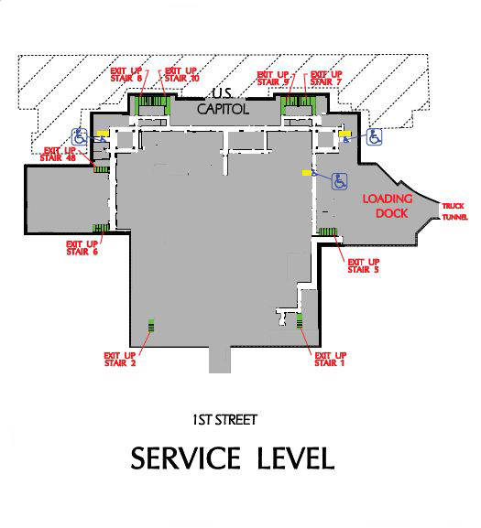

Emergency Evacuation Elevator Map – Senate Office Buildings
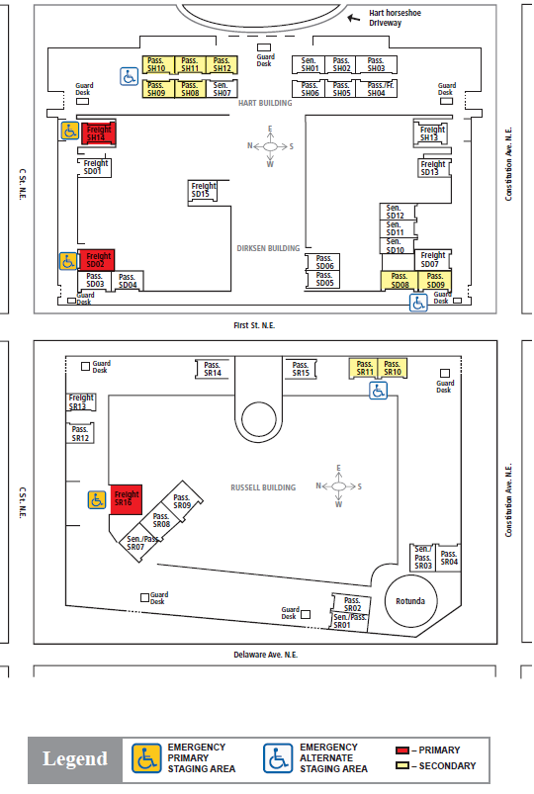

Escape Hood Public Caches in Senate Office Buildings

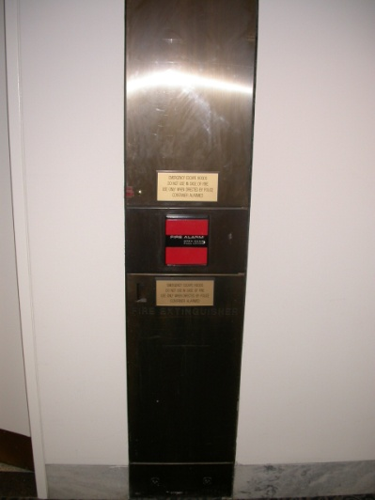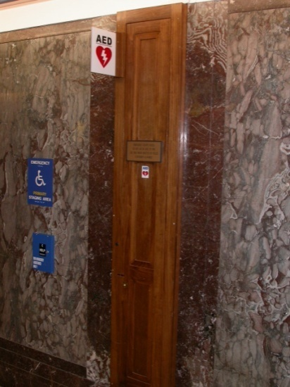

Hart Dirksen

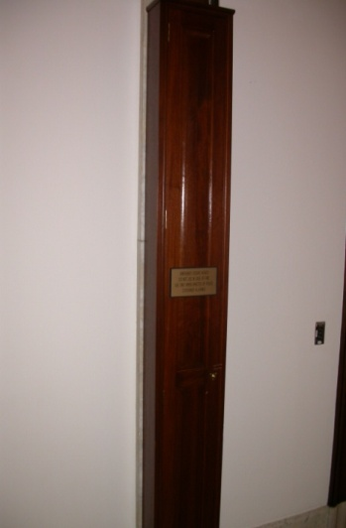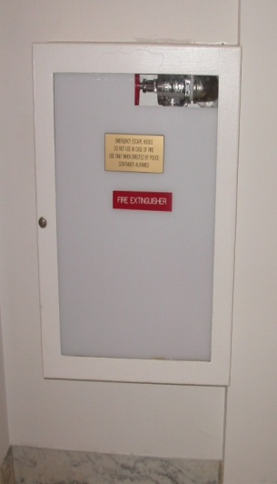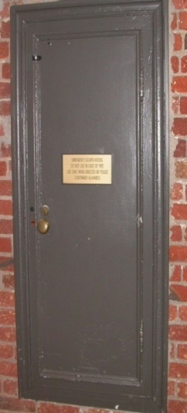

Russell

Escape Hood Public Caches in Senate Office Buildings

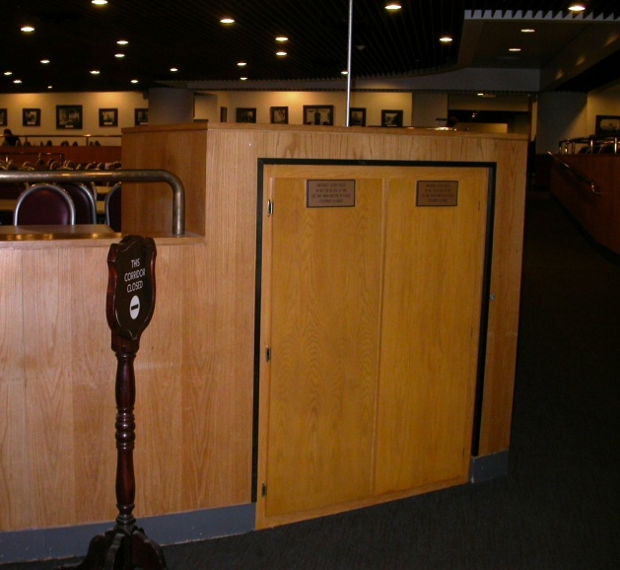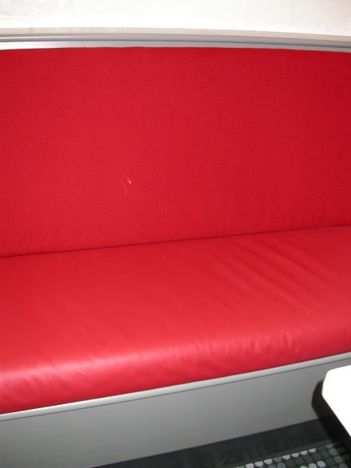

North Servery Cafeteria Capitol Carryout

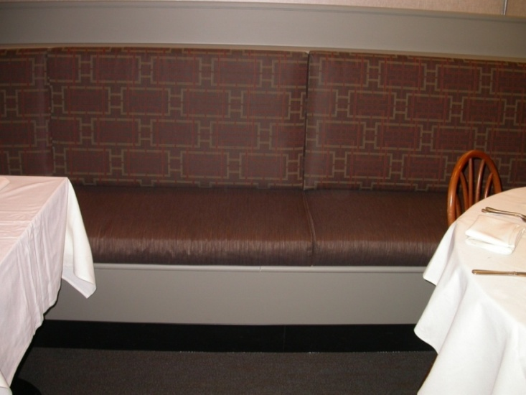

South Buffett

Escape Hood Caches in Senate Offices

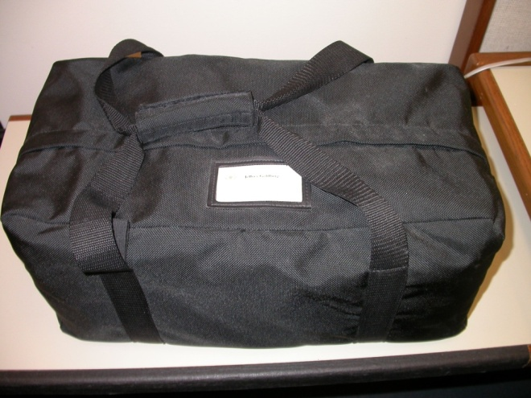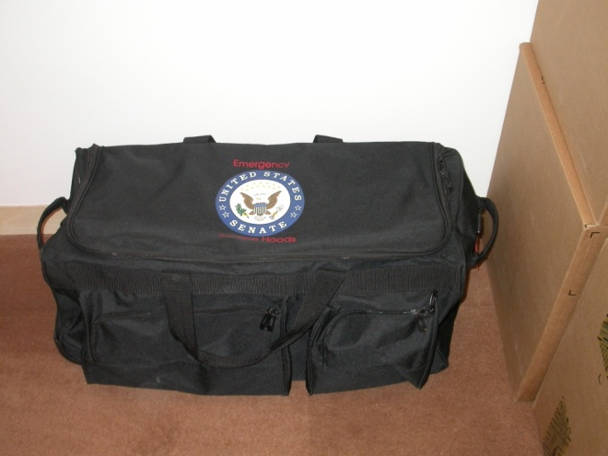

Small Bag of Escape Hoods Large Rolling Bag of Escape Hoods

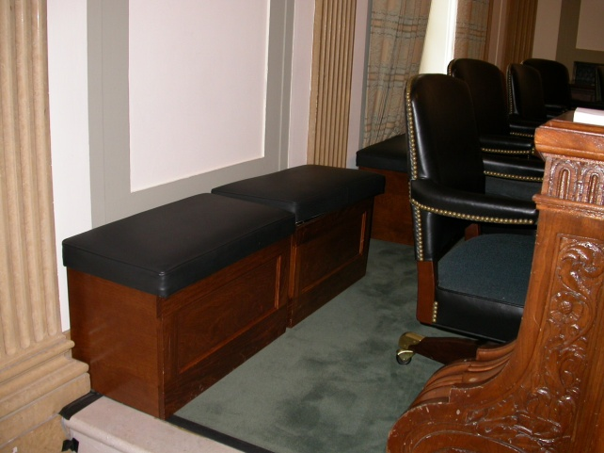

Committee Room Benches

Escape Hood Public Caches in Capitol

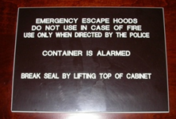

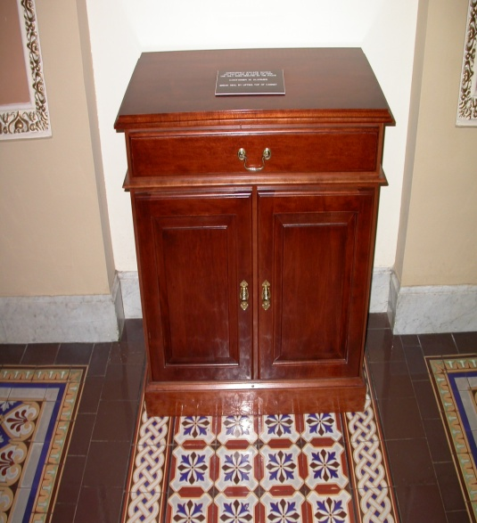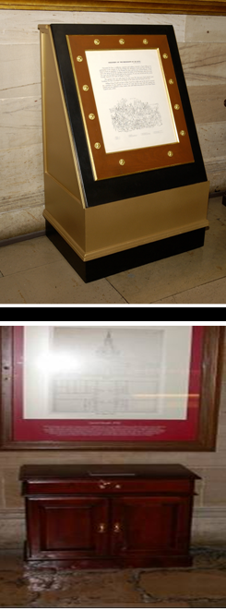

Hallways Rotunda

Crypt
Victim Rescue Unit (VRU) Public Caches in Senate Office Buildings

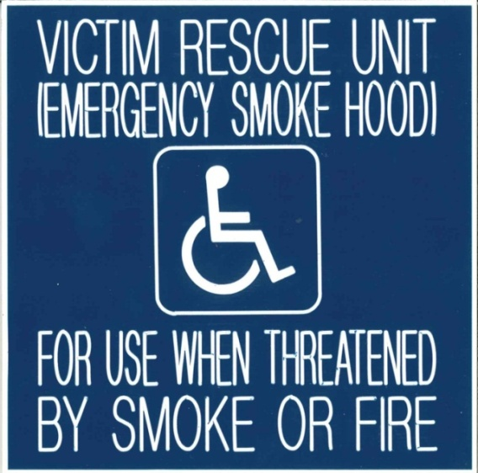

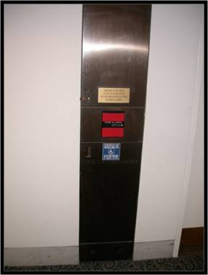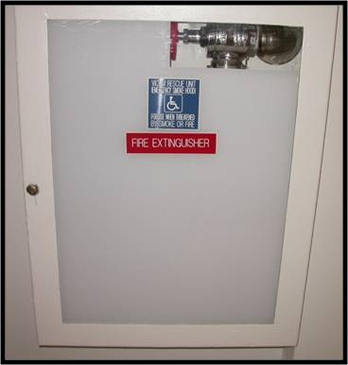

Hart Russell

Etiquette

It is important to maintain decorum and courtesy when interacting with constituents, including constituents with accessibility needs. Below are a few important guidelines to consider whether the person is a colleague, constituent, or visitor.

General
- People with accessibility needs are aware of what they can and cannot do. Always offer assistance before assisting.
- When assisting, ask for instructions and clarify what kind of assistance the person wants and needs. Leave this determination to the person.
- Respect all assistive devices (i.e. canes, wheelchairs, crutches, communication boards, service animals, etc.) as personal property. Unless given specific and explicit permission, do not move or touch them.
- Refrain from commenting on the user's ability to operate or use their assistive device.
- Always direct your communication to the person with accessibility needs (When talking to a person who is deaf using a sign language interpreter, direct your communication to the person and not the sign language interpreter.) If a person is accompanied, do not direct your comments to the aide.
- Use a typical speaking tone and style. If a louder voice is necessary, the person will ask you to raise your voice.
- Address people with accessibility needs by their first names only when extending the same familiarity to others.
- Remember that people with accessibility needs are interested in the same topics of conversation as people who do not have disabilities.

When Providing Accommodations: (for example, setting up meetings)
- Make it easy to ask for and obtain accommodations – clearly indicate verbally and in writing the availability of appropriate accommodations and modifications.
- Begin by opening a dialogue with the person to find out what needs (if any) exist.
- Often people may ask for accommodations without using the word “accommodation.”
- Don’t automatically steer people with accessibility needs to disability-only services.
- Similar to people without accessibility needs, people with accessibility needs are unique and accommodations will vary depending on the specific circumstance.
- Openness and creativity are important when working with a person with accessibility needs in determining appropriate and effective accommodations.
- Discussions about accommodations should remain private and confidential.
- Provide many opportunities for feedback from the person with accessibility needs.

For more information regarding proper etiquette in such areas as interviewing techniques and scheduling meetings please visit:

- The National Center on Birth Defects and Developmental Disabilities website at http://www.cdc.gov/ncbddd/.
  - Click on “People with Disabilities”
  - From there, click on “Disability and Health.”
  - On the right side of the page under ‘Topic Contents’ click on “Accessibility Guidelines.”

Language

There are some very important ways to talk with and write about a person with accessibility needs. If you are unsure of the proper term, always asks what the person prefers. The best way to refer to a person with accessibility needs is always by name. Below are a few examples:

Outdated or Offensive | Reason | Proper or Accepted
“The” name of group (disabled, blind, autistic) | Does not reflect the individuality, equality, or dignity of people with disabilities | People with disabilities  Deaf people  People who are blind  People who have low vision
Handicapped | Disabilities don’t handicap: attitudes and architecture handicap | People with disabilities
Disabled Person | Put person first, describe what a person is, not what a person has | Person with a disability
Normal, healthy, whole, able-bodied (when speaking of the non-disabled) | Implies that a person with a disability isn’t normal | Non-disabled  Person without a disability
Hearing impaired | Negative connotation of impaired | Deaf  Hard of Hearing
Wheelchair-bound, confined | Wheelchairs don’t confine, they make people mobile | Uses a wheelchair, wheelchair user
Retarded, Mentally Defective, Simple, Slow | Stigmatizing. Implies that a person cannot learn | Cognitive disability, developmental disability, intellectual disability
Midget | Considered offensive | Person of short stature
Cripple, Crippled | Dehumanizing | Has a disability, physical disability, mobility challenged
Suffers from | Negative connotation of suffers | Has a disability
Admits she has a disability | Disability is not something people admit to or needs to be admitted to | Says she/he has a disability

For an additional reference on people first language please visit:
- The Department of Labor website at http://www.dol.gov.
  - Click on “Office of Disability Employment Policy (ODEP).”
  - Click on “Publications”.
  - Click on “Disability and Workplace Culture.”
  - Click on “Effective Interaction: Communicating With and About People with Disabilities in the Workplace.”
Alternative Formatting

When developing materials please be aware that certain items are not accessible by all. Alternative formats may be necessary and should be available, while some items should be provided automatically. Below are a few guidelines for preparing alternative formats:

Portable Document Format (PDF)
- PDF format should not be used as it cannot be easily accessed by people who use screen readers.

Websites
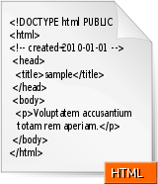
- An accessible website can be perceived, navigated, utilized (with a keyboard or devices other than a mouse), and easily understood (even in attention-poor situations).
- For more information on assuring accessibility in such situations visit The National Center on Birth Defects and Developmental Disabilities website at http://www.cdc.gov/ncbddd/.
  - Click on “People with Disabilities”
  - From there, click on “Disability and Health.”
  - On the right side of the page under ‘Topic Contents’ click on “Accessibility Guidelines.”

Large Print
- Print on single-sided 8.5x11” paper, stapled at top left corner.
- Use letter format.
- At a minimum use 18 pt fonts for all text. Larger fonts may be used for headings.
- Double-space lines and left justify all paragraphs.
- Keep 1” margins on all sides.
- Use bold serif font (Times New Roman) for body text and a bold simple non-serif font (Arial) for headings and other information that is set apart from body text.
- Make lines thick/heavy in charts and graphs.
- Use underlining for emphasis instead of italics.
- Do not use columns, bullets, decorative graphics, or boxed text.

Braille
- Conversion – To have a document converted to Braille, please contact OCAS for guidance. They will assist with the conversion process after which you will take it to the Printing, Graphics and Direct Mail Office (SD-G82, 202-224-6138). PGDM requires approximately 7 days to produce materials in braille.
- The number of people who use braille is decreasing, therefore it is good to also offer a document on a CD-ROM. The document should be in a Microsoft Word, or HTML format.

American Standard Code for Information Interchange (ASCII)
- These are files with special commands to indicate formatting information. ASCII format is the same as txt file format or notepad format. Using Notepad program to do word processing will by default give you a document in ASCII format or txt format. ASCII is used as opposed to MSWord documents or WordPerfect files.

PowerPoint
- PowerPoint presentations can be attractive, entertaining, and informative without flashing animation in contrasting colors.
- It is helpful to include a detailed explanation of the meaning of any charts or graphics used in the “Notes” section of all presentations. In addition, when presenting, take a moment to describe the visual message to the individual who is blind or of low vision.
Physical Accessibility

It is important to maintain a proactive approach when providing accommodations and not waiting to provide such accommodations when requested. Physical barriers should be considered in the effort to prevent discrimination on the basis of disability. The following checklist can help determine areas in the building and office that need improvement and should be kept on hand.

Accessible Route
- What is the route of travel that does not require the use of stairs?
- Is the route of travel stable, firm, and slip-resistant?
- Can all objects protruding into the circulation paths be detected by a person who is blind and uses a cane or has other accessibility needs? (Must be within 27 inches of the ground or must be higher than 80 inches; for example: state flag poles, shelves, fire extinguishers, boxes, furniture)
- Is there a 5-foot circle or T-shaped space for turning a wheelchair completely around in office entry ways and conference rooms?

Entrance
- Does the entrance door have at least a 32-inch clear opening?
- Is there at least 18 inches of clear space on the pull side of the door, next to the handle?
- If applicable, are carpeting or mats no more than ½ - inch high?
- Is the door handle no higher than 48 inches and operable with a closed fist?
- Can doors be opened with very little force? (Offices must provide staff who can open the door upon request.)
- If the door has a closer, does it take at least 3 seconds to close?

Seating
- Are the aisles between fixed seating (other than assembly area seating) at least 36 inches wide? (44 inches is preferred).
- Are the tops of tables or counters between 28 and 34 inches high?
- Are there accessible seats dispersed throughout the room rather than only seats in the front and back?
- Are knee spaces at accessible tables at least 27 inches high, 30 inches wide, and 19 inches deep?

Additional
- Are URL approved extension cords and tape on hand if use of an outlet is required? (Extensions cords may not be used for more than 90 days and cannot be chained together. If your office needs electrical distribution on a more permanent basis, you may use a multi-strip surge protector.)
- Is there an accommodation for possible service animals?

Accessible Hearing Rooms

Below is a checklist for executive sessions, hearings, and public meetings conducted by Committees to help ensure access and participation of individuals with accessibility needs.

_____ Have accommodations been requested? Examples include:
____ Sign Language Interpreter
____ Real time captioning
____ Braille
____ CD-ROM copies of all materials in Microsoft Word, or HTML format
____ Large print of all materials
____ Listening devices
____ Other

_____ Is the room accessible for attendees and witnesses who use wheelchairs, walkers, scooters, etc? Do not place persons in wheelchairs, or those who use walkers or service animals on the fringes or in a “special area.”

_____ Is there reserved seating in the front for someone who has low vision or
who is deaf to see the real-time captioning or the sign language interpreter?

Basic Example:
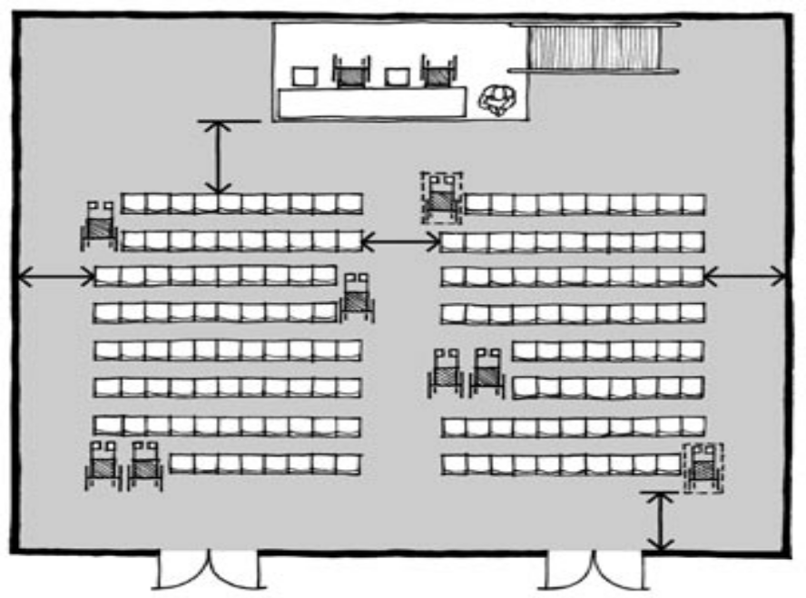

Enrichment and Training

Offices that would like training on the Americans with Disabilities Act (“ADA”) should contact the Office of the Senate Chief Counsel for Employment at (202-224-5424).
For class dates, times, and locations for the following trainings, contact the Office of Education and Training at (202-224-7628) or visit Webster.
  - On the left side of your screen, click “Education & Training.”

Communicating with Constituents with Disabilities
Did you know that one-fifth of all constituents might not be able to communicate with your office? Do you know what to do if someone who is deaf or blind walks in the door? Statistics show that one in five Americans will have a disability at some point in their life. Is your office equipped to communicate with and/or assist constituents with disabilities? The Office of Congressional Accessibility Services will conduct a one-hour program on increasing awareness and encouraging accessibility to Congress, as well as communicating with individuals with disabilities. This includes language use and the choice of words, sign language interpreters and other communication aids, accessible tours for constituents, and TTY phone information.

TTY/TDD –Telecommunication Device for the Deaf
Most Senate offices have a TTY/TDD. Did you know that this machine is a telephone that is used by people who are deaf, hard of hearing or have communication challenges? Does your office have one? Do you know where it is? Do you and your colleagues know the purpose and correct usage of this machine? This course will discuss the mechanics of the machine and proper etiquette and terminology while using it.

Emergency Planning Class for Staff with Disabilities
For years, staffers with disabilities have succeeded in creating and implementing emergency procedures designed to make everyone’s life safer and easier. At this class, participants will learn about best practices and protective actions on emergency preparedness and planning procedures at the Senate for persons with disabilities. A special emphasis will be placed on evacuation procedures, emergency staging area locations, emergency call boxes, and emergency equipment for use during emergencies.
Accessible Directions

Accessible Route to the Hart Senate Building
From Union Station Metro Station (Red Line)

- Exit the Metro train and take the elevator up to the exit toll level. (If the elevator is out of order, please listen to the overhead annunciator for instructions.)
- Pass through the exit toll and take a second set of elevators to the Mezzanine (M) level. (If the elevator is out of order, please listen to the overhead annunciator for instructions.)
- Follow the corridor to the right, passing through the automatic doors into Union Station.
- Travel straight and exit Union Station through the automatic doors, passing the escalators for the metro.
- Turn left and travel East down the outdoor corridor in front of Union Station, towards the Thurgood Marshall Federal Building, passing Columbus Circle.
- Turn right and travel straight until you reach Massachusetts Ave. NE.
- Turn left on Massachusetts Ave. NE and travel to 2nd Street NE.
- Turn right on 2nd Street NE and continue traveling straight.
- Midway on the block between C Street NE and Constitution Ave., turn right and use the accessible entrance on 2nd Street NE to enter the Hart Senate Office Building.

Accessible Route to the Russell Senate Office Building
From Union Station Metro Station (Red Line)

- Follow accessible route to the Hart Senate Building from Union Station Metro Station steps 1-8.
- Turn right on Constitution Ave. and travel straight until you reach Delaware Ave. NE.
- Turn right on Delaware Ave. NE and use the accessible entrance located on the corner of Delaware Ave. NE and Constitution Ave. NE to enter the Russell Senate Office Building.

Accessible Route to the Dirksen Senate Office Building
From Union Station Metro Station (Red Line)

- Follow accessible route to the Hart Senate Building from Union Station Metro Station steps 1-8.
- Turn right on C Street NE and travel straight until you reach 1st Street NE.
- Turn left and use the accessible entrance located on the corner of 1st Street NE and C Street NE to enter the Dirksen Senate Office Building.

Accessible Route to the US Capitol
From Union Station Metro Station (Red Line)

- Follow accessible route to the Hart Senate Building from Union Station Metro Station steps 1-8.
- Turn right on Constitution Ave. NE and travel straight until you reach 1st Street NE.
- Turn left on 1st Street NE, crossing Constitution Ave. NE.
- Turn right crossing 1st Street NE, so that you are on the Capitol side of 1st Street NE.
- Turn left proceeding down 1st Street NE, walk approximately 15 feet, and turn right onto Capitol Circle, NE and use the accessible entrance located at the North Entrance of the US Capitol.

Accessible Route to the Capitol Visitor Center
From Union Station Metro Station (Red Line)

- Follow accessible route to the Hart Senate Building from Union Station Metro Station steps 1-8.
- Turn right on Constitution Ave. NE and travel straight until you reach 1st Street NE.
- Turn left on 1st Street NE, crossing Constitution Ave. NE.
- Turn right crossing 1st Street NE, so that you are on the Capitol side of 1st Street NE.
- Turn left proceeding down 1st Street NE to East Capitol Street NE.
- Turn right onto East Capitol Street NE and travel down the ramps located on the right side that descend to the accessible lobby entrance of the Capitol Visitor Center. There are also elevators located on the plaza that will take you down to the entrance into the Visitor Center.

Accessible Route to the Cannon House Building
From Capitol South Metro Station (Orange and Blue Lines)

- Exit the Metro train and take the elevator up to the exit toll level. (If the elevator is out of order, please listen to the overhead annunciator for instructions.)
- Pass through the exit toll and take a second set of elevators to the street level. (If the elevator is out of order, please listen to the overhead annunciator for instructions.)
- Exit the elevator and turn left traveling east to the corner of 1st Street SE and D Street SE.
- Turn left and travel straight until you reach C Street SE.
- Turn left and travel straight until you reach New Jersey Avenue SE.
- Turn right on New Jersey Avenue SE, and travel straight.
- Midway on the block between C Street SE and Independence Ave. SE, turn right and use the accessible entrance on New Jersey Avenue SE to enter the Cannon House Office Building.

Accessible Route to the Longworth House Building
From Capitol South Metro Station (Orange and Blue Lines)

- Follow accessible route to the Cannon House Office Building from Capitol South Metro Station steps 1-4.
- Turn left on C Street SE and travel straight for two blocks to South Capitol Street SE.
- Turn right on South Capitol Street, and use the accessible entrance located on the corner of C Street SE and South Capitol Street to enter the Longworth House Office Building, OR use the accessible entrance located farther North on the corner of Independence Ave. SE and South Capitol Street to enter the Longworth House Office Building.

Accessible Route to the Rayburn House Building
From Capitol South Metro Station (Orange and Blue Lines)

- Follow accessible route to the Cannon House Office Building from Capitol South Metro Station steps 1-4.
- Turn left on C Street SE and travel straight for two blocks to South Capitol Street SE.
- Cross C Street SE, turn right and travel straight down South Capitol Street SE.
- Midway on the block between C Street SE and Independence Ave. SE, turn left and use the accessible entrance on South Capitol Street SE to enter the Rayburn House Office Building.

Accessible Route to the US Capitol
From Capitol South Metro Station (Orange and Blue Lines)

- Follow accessible route to the Cannon House Office Building from Capitol South Metro Station steps 1-4.
- Travel straight down 1st Street SE to Independence Ave. SE.
- Turn left proceeding down Independence Ave. SE, walk approximately 15 feet, and turn right to cross Independence Ave. SE.
- Turn left traveling West to Capitol Plaza SE, and use the accessible entrance located at the South Entrance of the US Capitol.

Accessible Route to the Capitol Visitor Center
From Capitol South Metro Station (Orange and Blue Lines)

- Follow accessible route to the Cannon House Office Building from Capitol South Metro Station steps 1-4.
- Travel straight down First Street SE to Independence Ave. SE.
- Turn left proceeding down Independence Ave. SE, walk approximately 15 feet, and cross Independence Ave. SE.
- Travel straight proceeding down First Street SE to East Capitol Street NE.
- Turn left onto East Capitol Street NE and travel down the ramps located on the left side that descend to the accessible lobby entrance of the Capitol Visitor Center. There are also elevators located on the plaza that will take you down to the entrance to the Visitor Center.
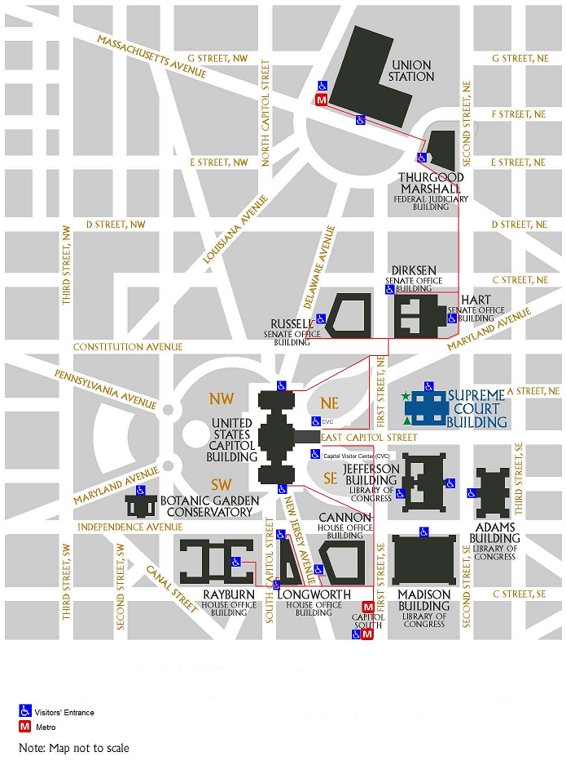
References

Office of Congressional Accessibility Services (OCAS)
Crypt of the US Capitol (1st Floor)
Phone: (202) 224-4048
TTY: (202) 224-4049
Fax: (202) 228-4679
URL: http://webster.senate.gov/AccessibilityServices/
Visit Webster http://webster.senate.gov/. Click on “Sergeant at Arms”. Click “Accessibility Services.”

Education and Training
Phone: (202) 224-7628
URL: http://webster.senate.gov/training/
Visit Webster http://webster.senate.gov/. On the left column, click on “Education and Training.”

Printing and Graphics
SD-G82
Hours: Monday-Friday 7:00AM - 11:30PM
Phone: (202) 224-6138
URL: http://webster.senate.gov/PGDM/
Visit Webster http://webster.senate.gov/. Click on “Services.” Under ‘Office Resources’, click on “Stationary & Printing.”

Capitol Police
119 D Street, NE
Phone: (202) 224-0908
URL: http://webster.senate.gov/CapitolPolice
Visit Webster http://webster.senate.gov/. Click on “Services”. Click on “Security and Emergency Planning.” Click on “Capitol Police.”

Police Operations, Security and Emergency Preparedness (POSEP)

SVC-305
Phone: (202) 228-6737 (8-OSEP)
URL: http://webster/POSEP/
Visit Webster http://webster.senate.gov/. On the left side, click on “POSEP.”

Senate Recording Studio
SVC-160
Phone: (202) 224-4977
URL: http://webster.senate.gov/RecordingStudio/
Visit Webster http://webster.senate.gov/. Click on “Sergeant at Arms”. Click “Audio Services”.

Architect of the Capitol
SB-15 Capitol
Ph: (202) 228-1793
URL: http://www.aoc.gov/ access through Webster
Visit Webster http://webster.senate.gov/ by clicking “Architect of the Capitol.”

Office of Senate Chief Counsel for Employment
103 Hart Senate Office Building
Ph: (202) 224-5424
URL: http://webster.senate.gov/secretary/departments/SCCE/
Visit Webster http://webster.senate.gov/. Click on “Secretary of the Senate”. On the left side, click on “Chief Counsel for Employment.”

Senator Enzi and his staff wish to thank the following organizations who provided information and helpful insight for this manual in the original edition (January 2008):

American Council of the Blind

Architect of the Capitol

Association of University Centers on Disabilities

Brain Injury Association of America

Office of Congressional Accessibility Serviecs

Easter Seals

Epilepsy Foundation

Gallaudet University

Goodwill Industries International

Institute for Educational Leadership

Judge David L. Bazelon Center for Mental Health Law

National Federation of the Blind

Office of Compliance

Sergeant at Arms

Telecommunications for the Deaf, Inc.

The Arc and United Cerebral Palsy Disability Policy Collaboration

United Spinal Association

Virginia Statewide Independent Living Council

